**POSTER DUE ON BLACKBOARD BY 5 PM ON THURSDAY 10/15**

**GALLERY: MONDAY 10/19 6-8 PM SHREVE LOBBY**

**BUSINESS CASUAL ATTIRE**

**Dinner @ Hillenbrand @ 6:30-7ish**

**NEXT MEETING: Wednesday 10/14 @ 9:30 pm**

**To DO: Replace images with higher quality pics, add conclusion, format text size add in-text, image of brain, separate references and acknowledgements. Make title larger if can. Body text no smaller than 22.**

USE arial, helvetica, tahoma; Poster size: 42x48 inches

**Title:** {in 72 pt font} Options:

IF YOU SMOKE WEED, YOUR KIDS WILL WORK FOR HEROIN.

Did your parents smoke weed? Have a craving for heroin? Its normal!

THC Usage Leads to Generations of Offspring with Drug Seeking behavior

******Parental THC Usage Leads to Drug Seeking Behavior in Subsequent Generations

**Authors and Institutional Affiliation:** {in 48 pt font}

{1st line} Kate Adams, Kathryn Atherton, Jared Boyden, Margaret Christy, Chrishan Fernando, Mekenzie Gear, Madison Smith

{2nd line} Purdue University (Include logo), Purdue Honors College (Include image)

**Background:** {in 48 pt font}

[Flow] Classical genetics → evolution to epigenetics (used to be set in stone now more fluid; methylation/acetylation) → previous studies → why it matters ?

[Poster text]

* Classical genetics is marked by genetic determinism - the idea that each generation’s genetic expression is unaffected by the experiences of prior generations.
* Epigenetics is the study of changes in gene expression that do not involve alterations to the DNA sequence but are still passed down to subsequent generations.
* Chemical tags (methyl and acetyl groups) can be attached to or removed from segments of DNA. These tags cause DNA to be expressed at a lower or higher level, respectively. Methyl groups cause DNA to coil and prevent it from being read. On the other hand, acetyl groups cause DNA to unwind and make it easier to be read. These chemical tags together make up what is known as the epigenome.
* Various studies have examined the long-term impact of drug use on an individual (Whan, West, Mcclure, Lewis; 2006); however, this study researched the effects on subsequent generations and found drug exposure in adult rats negatively affected their offspring.

**Main Question:** {in 48 pt font}

Does transmission of cannabis-induced epigenetic changes contribute to the development of drug-seeking behaviors in the following generations?

***Does cannabis use during adolescence cause epigenetic changes that lead to drug-seeking behaviors in subsequent generations?

**Results:** {in 48 pt font}

-Visuals (communicate your key points)

-figure title (main finding of that experiment & significance, connect to main ?

-figure legend

**Full size images: http://www.ncbi.nlm.nih.gov/pubmed/24385132**

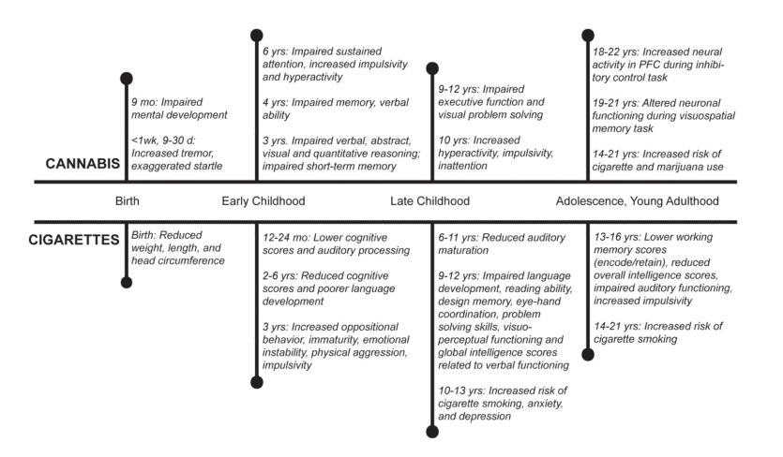

<http://www.ncbi.nlm.nih.gov/pmc/articles/PMC3226730/pdf/nihms322776.pdf> (pg 19)

“*Effects of prenatal and in utero cannabis and cigarette use”*

This figure shows the effects that cannabis and cigarette use by mothers before their child’s conception and during pregnancy have on the offspring.

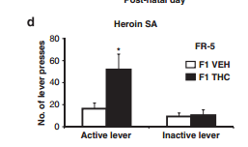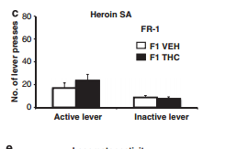

These two figures show how much effort F1 THC mice were willing to put forth to self administer the heroin veresus the effort put forth by the F1 VEH mice. Figure a shows the number of lever presses with a fixed ratio of 1 lever press. Figure b shows the number of lever presses with a fixed ratio of 5 lever presses.

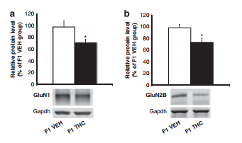

**Figure 3: Abnormal NMDA Receptor Subunit Levels**

These two figures demonstrate the protein level of F1 THC mice relative to F1 VEH at 100%. Both figures show levels detected by western blotting. Figure (3a) shows GluN1 levels, figure (3b) shows GluN2B levels, and gapdh serves as the control. The F1 THC mice show a decreased expression of each receptor subunit protein.

**Conclusions:** {in 48 pt font}

While the F1 THC and F1 VEH groups responded roughly the same for the FR-1 level tests, the F1 THC group pressed the level much more than the F1 VEH group on the FR-5 schedule. These results demonstrate that the offspring of the F0 THC rats were more willing to work for heroin which suggests that adolescent THC usage in the F0 THC rats likely contributed to drug-seeking behavior in their offspring.

While the study did not examine methylation and acetylation patterns directly, the authors looked at protein levels to examine the potential for epigenetic effects as a cause for the increased drug-seeking behavior in offspring. The study found lower levels of the glutamate receptor subunits GluN1, GluN2B, and Gapdh in the F1 THC group than the F1 VEH group. Glutamate receptors are implicated in drug addiction. Furthermore, decreased levels of these proteins suggest that the genes that code for them are being inhibited (methylated?). This means that the F0 THC rats may have passed drug-seeking behavior to the F1 rats via epigenetic effects.

**Implications or Significance to Humans:** {in 48 pt font}

While it is unethical to perform experiments such as these on humm ans, there have been longitudinal studies that may corroborate the findings of the THC study in the rat model. For example, longitudinal studies such as the Ottawa Prenatal Prospective Study (Fried PA, Watkinson B, Gray R. 2003) and the Maternal Health Practices and Child Development Project (Goldschmidt L, Richardson GA, Willford J, Day NL. 2008) have shown that maternal usage of cannabis during pregnancy demonstrates a positive correlation with increased drug usage in offspring. Similarly, research has been done on the effects of THC on male fertility, and was found to decrease sperm motility and functionality (Whan, West, McClure, Lewis. 2006)

The rat model study is a traditional study that shows a much clearer link between THC usage in parents and drug-seeking behavior in offspring. Although experiments such as these cannot be tested on humans, the rat model is close enough to humans that these results could signify similar results in humans. If use of drugs such as marijuana and cocaine hold effects on offspring, the social and medical results alone are extreme. Perhaps younger generations could sue their fathers for their past mistakes. If citizens face drug addiction or weight gain due to their parents or grandparents using drugs, the users could be held responsible. The overall effects of epigenetics could lead the human race down a slippery slope. Certain triggers could be set off in order to create the perfect combination of gene expressions. Fatal or life changing diseases or conditions could be treated.However, the implications of changing these genomes could create more problems than the medical field is ready to face.

**References:** {in 48 pt font}

Ellgren, M., Spano, S., & Hurd, Y. (2007). Adolescent Cannabis Exposure Alters Opiate Intake And Opioid Limbic Neuronal Populations In Adult Rats. Neuropsychopharmacology, 607-615. (<http://www.researchgate.net/publication/6962446_Adolescent_Cannabis_Exposure_Alters_Opiate_Intake_and_Opioid_Limbic_Neuronal_Populations_in_Adult_Rats>) **KATE WILL READ THIS ONE**

Everitt BJ, Robbins TW (2013). From the ventral to the dorsal striatum: devolving views of their roles in drug addiction. Neursci Biobehav Rev 37 (Pt A): 1946-1954 (drug addiction) (<http://www.sciencedirect.com/science/article/pii/S0149763413000468>) **MEKENZIE**

use → abuse → addiction

occurs in the striatum

Transition from voluntary to habitual and progressively compulsive drug use is the result of dynamic shifts in the neural loci of control over behavior, from the ventral to dorsal striatum, mediated by its stratified dopaminergic innervation, together with a progressive decrease in prefrontal cortical control over drug seeking and drug taking behavior.

Szutorisz, H., Dinieri, J., Sweet, E., Egervari, G., Michaelides, M., Carter, J., . . . Hurd, Y. (2014). Parental THC Exposure Leads to Compulsive Heroin-Seeking and Altered Striatal Synaptic Plasticity in the Subsequent Generation. Neuropsychopharmacology. **<--Main Paper JARED WILL READ THIS ONE**

Vassoler, F., Johnson, N., & Byrnes, E. (2013). Female adolescent exposure to cannabinoids causes transgenerational effects on morphine sensitization in female offspring in the absence of in utero exposure. Journal of Psychopharmacology, 1015-1022. (cross genders) (<http://www.ncbi.nlm.nih.gov/pubmed/24048098>) **MAGGIE**

Vassoler FM, White SL, Schmidt HD, Sadri-Vakili G, Pierce RC (2013). Epigenetic inheritance of a cocaine-resistance phenotype. *Nat Neursci* 16: 42-47. **KATIE**

**Cocaine reprograms the male germline through an epigenetic mechanism (that is, acetylation), resulting in the inheritance of a neuronal and associated behavioral phenotype.**

**(**[**http://www.nature.com/neuro/journal/v16/n1/full/nn.3280.html**](http://www.nature.com/neuro/journal/v16/n1/full/nn.3280.html)**)**

Whan, L., West, M., Mcclure, N., & Lewis, S. (2006). Effects Of Delta-9-tetrahydrocannabinol, The Primary Psychoactive Cannabinoid In Marijuana, On Human Sperm Function In Vitro. Fertility and Sterility, 653-660. (<http://www.researchgate.net/publication/7277793_Whan_LB_West_MC_McClure_N_Lewis_SE._Effects_of_delta-9-tetrahydrocannabinol_the_primary_psychoactive_cannabinoid_in_marijuana_on_human_sperm_function_in_vitro._Fertil_Steril_85_653-660>) (humans) **Maddie**

**Sorry summary is very long**

**The main goal of this study is to find out the the effects of marijuana(THC) on sperm motility and acrosome reaction(reaction that occurs when the sperm binds to female egg) in order to raise awareness of the harmful effects marijuana can have on male fertility. Marijuana use, ever since the government has legalized it in varying circumstances, has risen to the top of most commonly used recreational drugs globally. Whether it be for therapeutic usage for multiple sclerosis, people with AIDS, or cancer chemotherapy, marijuana consumption affects a large percentage of males who are of reproductive age. Much research has been done on THC’s effects on the female reproductive cycle, but not as much research has been performed on the males. There has been very little research done on the topic of relating marijuana consumption to male reproduction, and overall, has varied results. Some prior tests many years ago showed that it had no effect at all, but recent tests have shown that it does negatively impact the amount of sperm concentration, motility, and morphology. The group took semen samples from 78 men 26-42 years old and divided them into two groups, one that was the normal sperm concentration (referred to as 90%) and the other that had low fertility and a smaller concentration of sperm(referred to as 45%). They then incubated these samples with THC. The results found that THC decreased sperm motility and sperm acrosome in both types of samples, however the 45%(low fertility) sample was affected significantly more. In the discussion, the authors explain that the reason this occurs is because certain cannabinoid receptors on sperm ’s pathways, which are very similar to ones found in the brain, are disrupted by THC. THC is also found to disrupt mitochondrial function, which reduces the amount of ATP produced, thus decreasing sperm motility. However, the article states that although THC can place stress on cells that could contribute to cellular damage, other studies have shown that cannabinoid receptors could actually protect sperm against stress. The group’s last conclusion that the disruption by a THC molecule, which is lipophilic, could cause an immense change in signal transduction. Overall, the group has many theories about why THC can affect sperm motility and acrosome reaction, but have come to the conclusion that sperm may be negatively affected by THC, especially sperm of already low fertility.**

<http://www.ncbi.nlm.nih.gov/pmc/articles/PMC3226730/pdf/nihms322776.pdf> (Page 9) Chrishan; It was long. I only read the good parts. Note that this is the same lab as the main paper. Pretty sure no one else researches THC’s effects on epigenetics

* <http://www.ncbi.nlm.nih.gov/pubmed/12798960>
  + Fried PA, Watkinson B, Gray R. Differential effects on cognitive functioning in 13- to 16-year-olds prenatally exposed to cigarettes and marihuana. Neurotoxicol Teratol. 2003;25:427–436.
* <http://www.ncbi.nlm.nih.gov/pubmed/18216735>
  + Goldschmidt L, Richardson GA, Willford J, Day NL. Prenatal marijuana exposure and intelligence test performance at age 6. J Am Acad Child Adolesc Psychiatry. 2008;47:254–263.

<http://www.ncbi.nlm.nih.gov/pmc/articles/PMC2780862/>

<http://ac.els-cdn.com/S0306987709002916/1-s2.0-S0306987709002916-main.pdf?_tid=dfbf11ea-6e14-11e5-8a4f-00000aacb362&acdnat=1444347343_605a50a2c617da26f9ee132d6a78ddc2>

**Acknowledgements:** {in 48 pt font}

Jake Brosius; acknowledgments should be full sentences

zoom in and screen capture

show picture of region of the brain

describe pleasure system of the brain (link to image above)

reference text can be smaller (other text minimum size: 20pt)

does anyone have photoshop? i do not

This figure shows the …. section of the brain. The LTD in the dorsal section of the brain was larger than in the main striatum. In addition, “LTD in dorsal striatium was significantly larger with a main effect of parental treatment in offspring of THC-exposed parents… These findings demonstrate that that parental THC exposure leads to a significant cross-generational effect on dorsal striatal LTD in adult offspring” (Szutorisz; 2014).

CITE AT END OF 3RD BULLET POINT: (Fried, 2003)

CITE AT END OF CONCLUSIONS OR IN CONCLUSIONS: (Szutorisz, 2014).

CITE AFTER WORD EXTREME IN IMPLICATIONS: (Vassoler, 2013).

